CURCUMIN
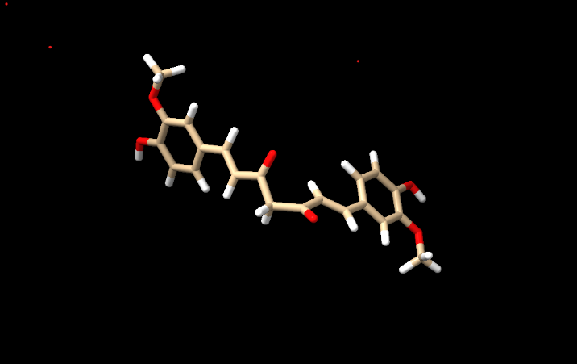
- Info
1 models
#1, pubchem:969516, shown
47 atoms, 48 bonds, 1 residues, 0 chains ( )

- Tools Structure Editing Add Hydrogens
Select also consider H bonds over steric only and press OK.
Summary of feedback from adding hydrogens to pubchem:969516 #1
notes Chain-initial residues that are actual N termini:
Chain-initial residues that are not actual N termini:
Chain-final residues that are actual C termini:
Chain-final residues that are not actual C termini:
0 hydrogen bonds
0 hydrogens added
pH need not be entered in chimera since it takes the charge at pH 7.0. so all the protonated states in option section of the addh dialogue box have to left at default.
- Tools Structure Editing Add Charges
Assigning partial charges to residue UNL (net charge +0) with gasteiger method
These messages mean:
- ChimeraX recognized the ligand as UNL (unknown ligand).
- The ligand was assigned a net charge of 0.
- Gasteiger partial charges were calculated using ANTECHAMBER.

- Select solvent
Nothing selected. Typically, ligands obtained from PubChem have no solvent.

- Delete sel
- Tools Structure Editing Minimize structure
step 100: energy -206.7
step 200: energy -206.9
decrease in energy i.e. more negative means the structure is more stable since the change is energy is not large, which indicates the structure was fairly stable to begin with.

RESVERATROL
File open structure file

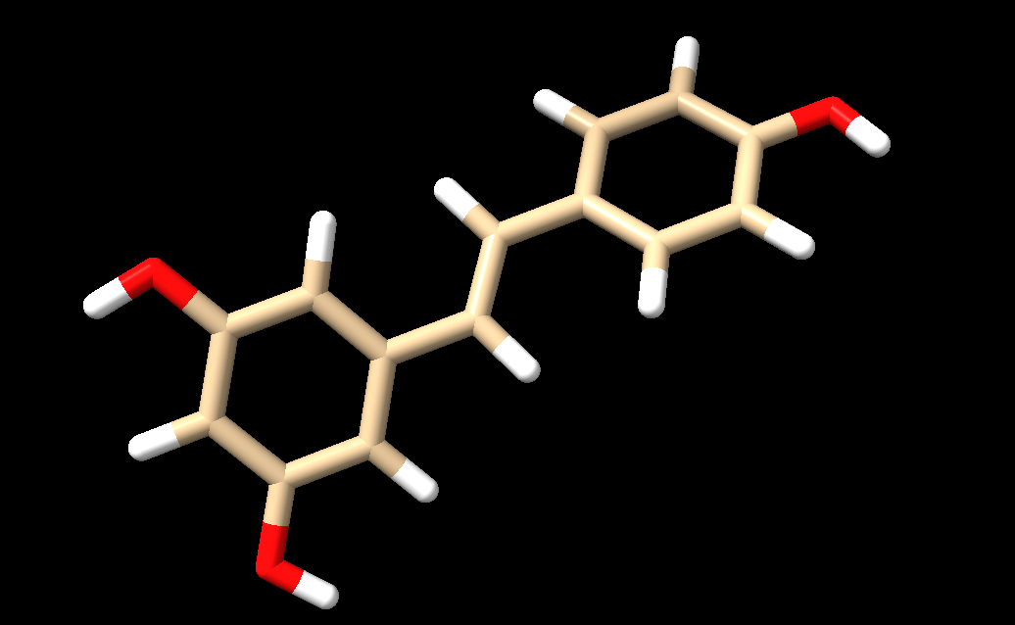

- Info
1 models
#1, pubchem:445154, shown
29 atoms, 30 bonds, 1 residues, 0 chains ( )

- Tools Structure Editing Add Hydrogens
Select also consider H bonds over steric only and press OK. Unspecified. Use idealized template
Summary of feedback from adding hydrogens to pubchem: 445154 #1
notes Chain-initial residues that are actual N termini:
Chain-initial residues that are not actual N termini:
Chain-final residues that are actual C termini:
Chain-final residues that are not actual C termini:
0 hydrogen bonds
0 hydrogens added
pH need not be entered in chimera since it takes the charge at pH 7.0. so all the protonated states in option section of the addh dialogue box have to left at default.
- Tools Structure Editing Add Charges
Assigning partial charges to residue UNL (net charge +0) with gasteiger method
Running ANTECHAMBER
These messages mean:
- ChimeraX recognized the ligand as UNL (unknown ligand).
- The ligand was assigned a net charge of 0.
- Gasteiger partial charges were calculated using ANTECHAMBER.

- Select solvent
Nothing selected. Typically, ligands obtained from PubChem have no solvent.

- Delete sel
- Tools Structure Editing Minimize structure
Dock prep finished
step 100: energy -290.0
step 200: energy -296.4
step 300: energy -296.9
decrease in energy i.e. more negative means the structure is more stable. This is only about a 2.4% decrease in energy, and most of the improvement occurred between steps 100 and 200. Between steps 200 and 300, the energy changed by only 0.5 units, suggesting the structure is approaching a local minimum.
What this generally means:
The added hydrogens and side chains were adjusted to relieve minor steric clashes.
No major rearrangement of the protein backbone is likely.
The structure appears reasonably stable before minimization.
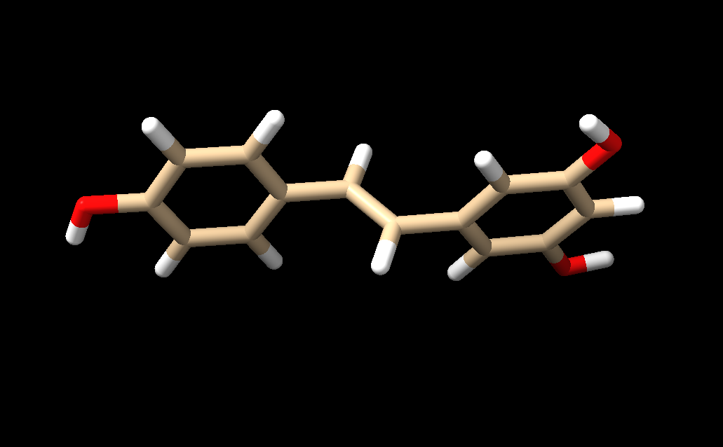
There was little change since the rings and the bonds between them are not in same plane now
Verification:
Matchmaker could not be run on the ligands it is for proteins only so perform rmsd (root mean square deviation) is a measure of the average distance between corresponding atoms in two structures after they have been optimally superimposed.
In structural biology, it tells you how similar or different two molecular structures are.
< 0.5 Å → Very little change
0.5–1.0 Å → Small change
1.0–2.0 Å → Moderate change
> 2.0 Å → Large conformational change
- rmsd #2 (minimized) to #1 (unminimized)
A single rotatable group that has rotated significantly.
Preservation of ring systems (rings should usually overlap well).
No broken bonds or distorted aromatic rings.
For docking

An RMSD of ~1.6 Å after ligand minimization is generally acceptable if:

The chemical structure is unchanged.
Ring geometries remain reasonable.
The new conformation is energetically favorable.

QUERCETIN
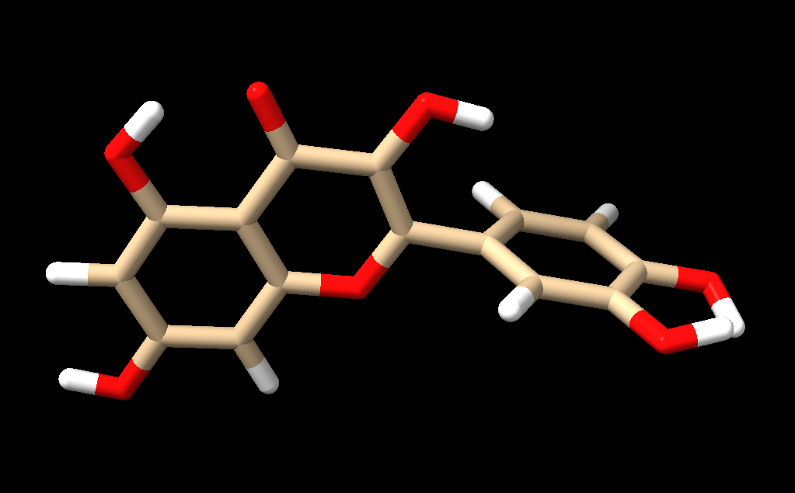
- info
1 models
#1, pubchem:5280343, shown
32 atoms, 34 bonds, 1 residues, 0 chains ( )
- Tools Structure Editing Add Hydrogens
0 hydrogen bonds
0 hydrogens added
- Tools Structure Editing Add Charges
Using Amber 20 recommended default charges and atom types for standard residues
Assigning partial charges to residue UNL (net charge +0) with am1-bcc method
Running ANTECHAMBER command: C:/Program Files/ChimeraX
- Tools Structure Editing Minimize structure
step 100: energy -343.5
step 200: energy -358.3
- rmsd #2 to #1
RMSD between 32 atom pairs is 0.413, indicating very little change in structure

EPIGALLOCATECHIN

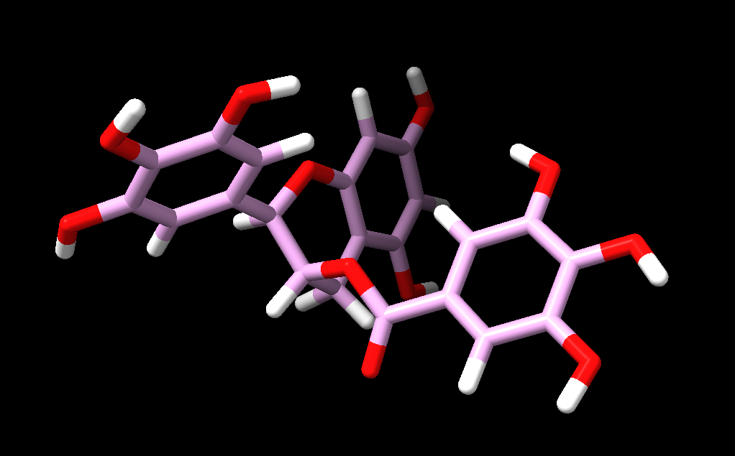
- info
1 models
#3, pubchem:65064, shown
51 atoms, 54 bonds, 1 residues, 0 chains ( )
- Tools Structure Editing Add Hydrogens
0 hydrogen bonds
0 hydrogens added
- Tools Structure Editing Add Charges
Using Amber 20 recommended default charges and atom types for standard residues
Assigning partial charges to residue UNL (net charge +0) with am1-bcc method
Running ANTECHAMBER command: C:/Program Files/ChimeraX
- Tools Structure Editing Minimize structure
step 100: energy -191.5
step 200: energy -195.3
step 300: energy -195.9
- rmsd #2 to #1
RMSD between 51 atom pairs is 0.589, indicating small change in structure

BATIMASTAT
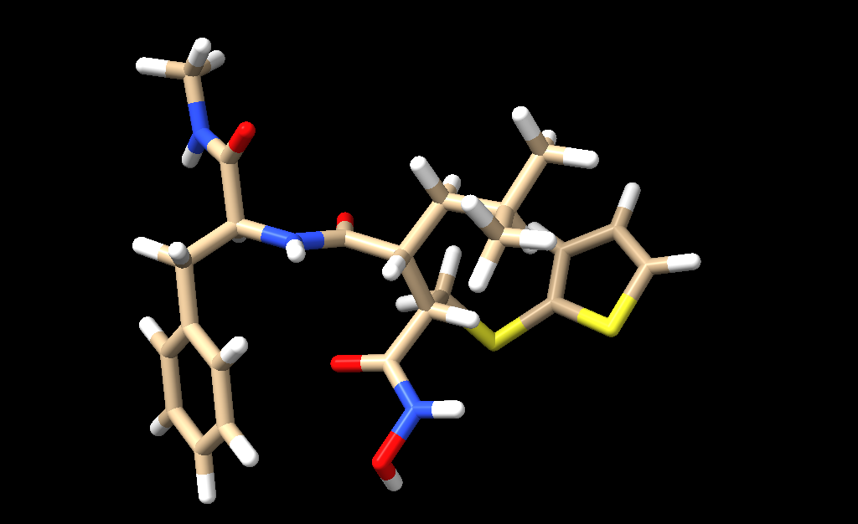
- info
1 models
#1, pubchem:5362422, shown
63 atoms, 64 bonds, 1 residues, 0 chains ( )
- select solvent
nothing selected
- Tools Structure Editing Add Hydrogens
0 hydrogen bonds
0 hydrogens added
- Tools Structure Editing Minimize structure
step 100: energy 131.1
step 200: energy 125.0
step 300: energy 123.3
step 400: energy 120.7
step 500: energy 111.3
step 600: energy 100.1
step 700: energy 97.6
step 800: energy 96.7
- Tools Structure Editing Add Charges
Using Amber 20 recommended default charges and atom types for standard residues
Assigning partial charges to residue UNL (net charge +0) with am1-bcc method
Running ANTECHAMBER command: C:/Program Files/ChimeraX

- rmsd #2 to #1
RMSD between 63 atom pairs is 2.157, indicating a large conformational change.
The chemical structure is unchanged.
Ring geometries remain reasonable.
The new conformation is energetically favorable.

MARIMASTAT
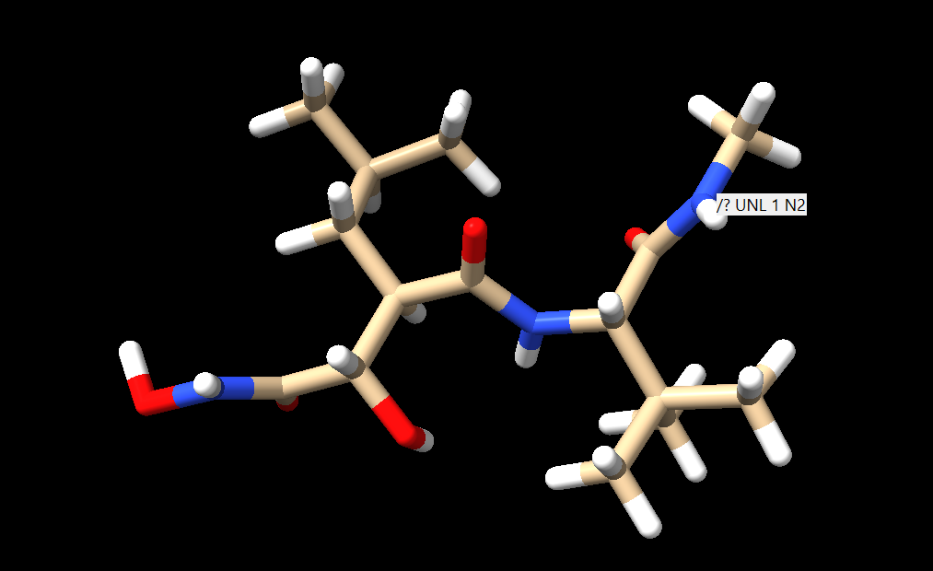
- Info
1 models
#1, pubchem:119031, shown
52 atoms, 51 bonds, 1 residues, 0 chains ( )
- select solvent
nothing selected
- Tools Structure Editing Add Hydrogens
0 hydrogen bonds
0 hydrogens added
- Tools Structure Editing Minimize structure
step 100: energy 195.4
step 200: energy 187.3
step 300: energy 182.7
step 400: energy 180.6
step 500: energy 153.7
step 600: energy 152.4
step 700: energy 152.5
- Tools Structure Editing Add Charges
Using Amber 20 recommended default charges and atom types for standard residues
Assigning partial charges to residue UNL (net charge +0) with am1-bcc method
Running ANTECHAMBER command: C:/Program Files/ChimeraX

- rmsd #2 to #1
RMSD between 52 atom pairs is 1.258, indicating a moderate conformational change.
The chemical structure is unchanged.
Ring geometries remain reasonable.
The new conformation is energetically favorable.

ILOMASTAT
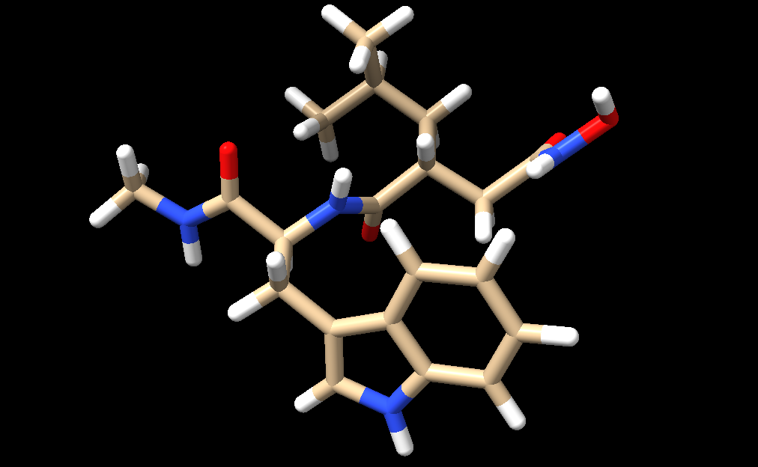

- Info
1 models
#1, pubchem:132519, shown
56 atoms, 57 bonds, 1 residues, 0 chains ( )
- select solvent
nothing selected
- Tools Structure Editing Add Hydrogens
0 hydrogen bonds
0 hydrogens added
- Tools Structure Editing Minimize structure
step 100: energy 140.1
step 200: energy 124.2
step 300: energy 122.4
- Tools Structure Editing Add Charges
Using Amber 20 recommended default charges and atom types for standard residues
Assigning partial charges to residue UNL (net charge +0) with am1-bcc method
Running ANTECHAMBER command: C:/Program Files/ChimeraX

- rmsd #2 to #1
RMSD between 56 atom pairs is 0.842, indicating a small conformational change.

DOXYCYCLINE
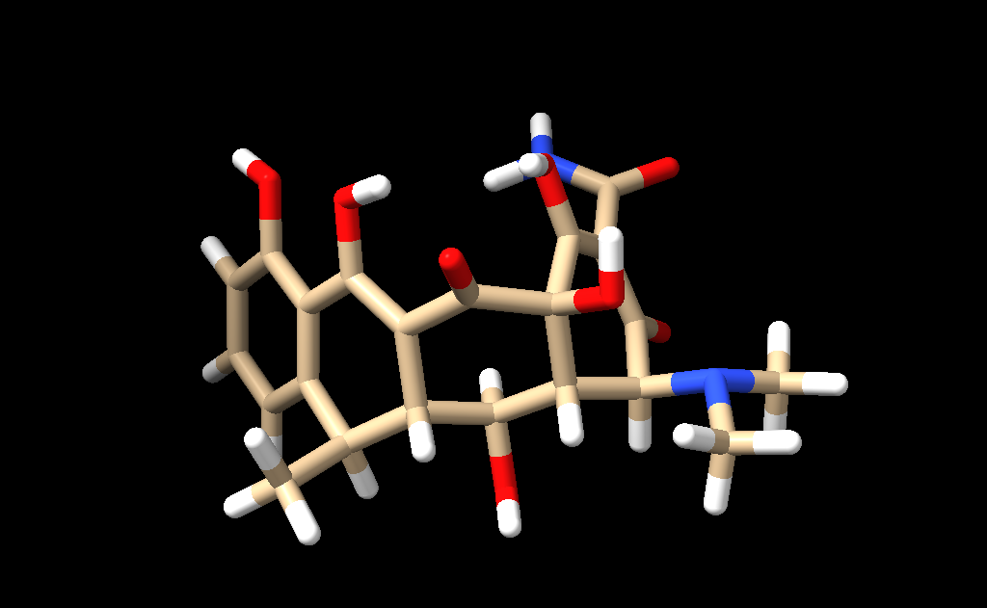
- Info
1 models
#1, pubchem:54671203, shown
56 atoms, 59 bonds, 1 residues, 0 chains ( )
- select solvent
nothing selected
- Tools Structure Editing Add Hydrogens
0 hydrogen bonds
1 hydrogens added
- Select chemistry element H
25 atoms, 1 residue, 1 model selected
- Tools Structure Editing Add Charges
Using Amber 20 recommended default charges and atom types for standard residues
Assigning partial charges to residue UNL (net charge +0) with am1-bcc method
Running ANTECHAMBER command: C:/Program Files/ChimeraX
- Tools Structure Editing Minimize structure
step 100: energy 8.6
step 200: energy -8.9
step 300: energy -43.2
step 400: energy -63.4
step 500: energy -71.9

- rmsd #2 to #1
The rmsd was determined after adding hydrogen to the original structure.
RMSD between 57 atom pairs is 2.0, indicating a moderate conformational change.
No change number of rings for positioning of atoms
Number of atoms from first atom spec (57) differs from number in second (56), since 1 H was added to prepared ligand

CAFFIENE
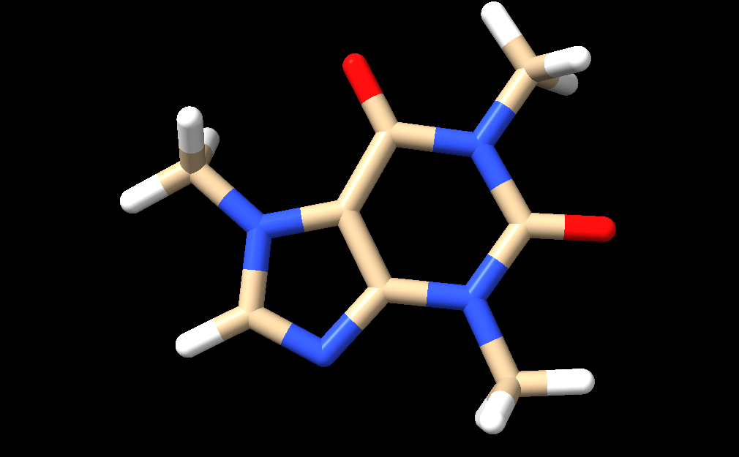
- Info
1 models
#1, pubchem:2519, shown
24 atoms, 25 bonds, 1 residues, 0 chains ( )
- select solvent
nothing selected
- Select chemistry element H
10 atoms, 1 residue, 1 model selected
- Tools Structure Editing Add Hydrogens
0 hydrogen bonds
0 hydrogens added
- Tools Structure Editing Add Charges
Using Amber 20 recommended default charges and atom types for standard residues
Assigning partial charges to residue UNL (net charge +0) with am1-bcc method
Running ANTECHAMBER command: C:/Program Files/ChimeraX
- Tools Structure Editing Minimize structure

- rmsd #2 to #1
RMSD between 24 atom pairs is 0.060, indicating very little conformational change.

EUGENOL
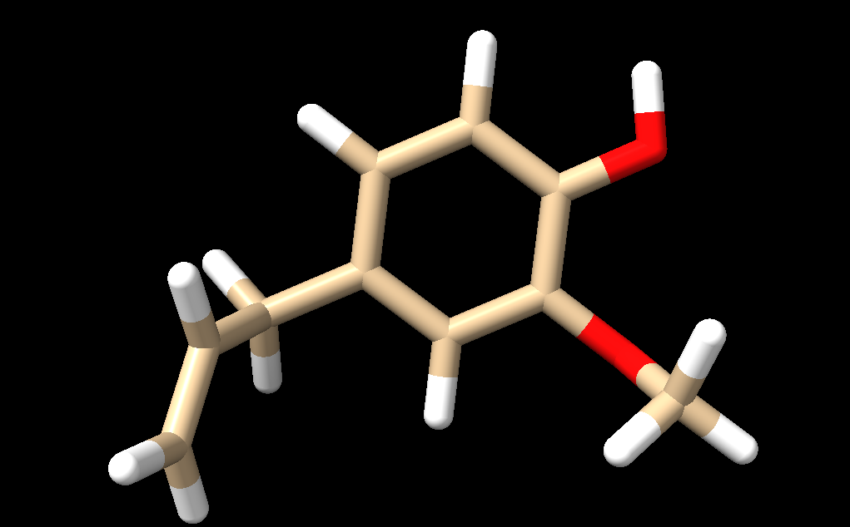
- Info
1 models
#1, pubchem:3314, shown
24 atoms, 24 bonds, 1 residues, 0 chains ( )
- select solvent
nothing selected
- Select chemistry element H
12 atoms, 1 residue, 1 model selected
- Tools Structure Editing Add Hydrogens
0 hydrogen bonds
0 hydrogens added
- Tools Structure Editing Add Charges
Using Amber 20 recommended default charges and atom types for standard residues
Assigning partial charges to residue UNL (net charge +0) with am1-bcc method
Running ANTECHAMBER command: C:/Program Files/ChimeraX
- Tools Structure Editing Minimize structure
step 100: energy 29.6
step 200: energy 20.6
- rmsd #2 to #1
RMSD between 24 atom pairs is 0.742, indicating small conformational change.

PIPERINE
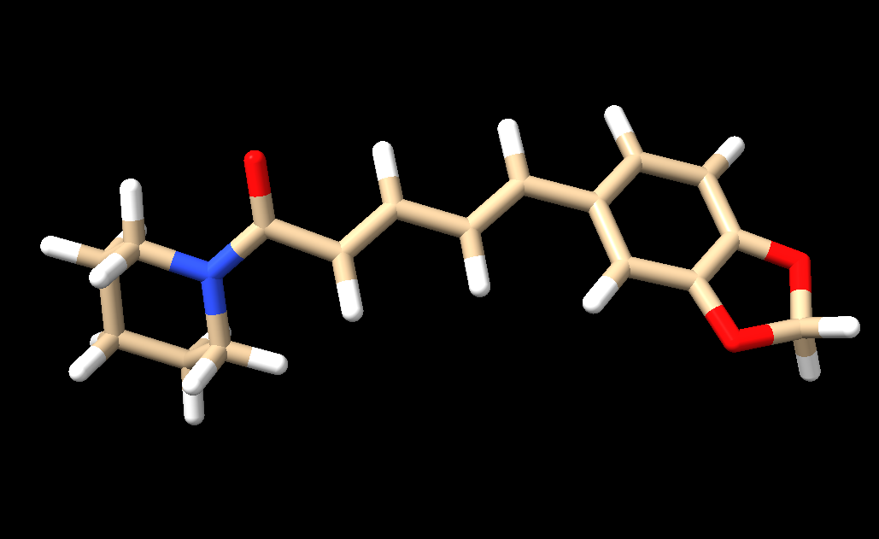
- Info
1 models
#1, pubchem:638024, shown
40 atoms, 42 bonds, 1 residues, 0 chains ( )
- select solvent
nothing selected
- Select chemistry element H
19 atoms, 1 residue, 1 model selected
- Tools Structure Editing Add Hydrogens
0 hydrogen bonds
0 hydrogens added
- Tools Structure Editing Add Charges
Using Amber 20 recommended default charges and atom types for standard residues
Assigning partial charges to residue UNL (net charge +0) with am1-bcc method
Running ANTECHAMBER command: C:/Program Files/ChimeraX
- Tools Structure Editing Minimize structure
step 100: energy 88.0
step 200: energy 86.2
- rmsd #2 to #1
RMSD between 40 atom pairs is 0.513, indicating small conformational change.

